Amazon Fresh Analytics
Problem Statement:
Amazon Fresh is an e-commerce platform specializing in groceries and daily essentials. As the platform expands, its management seeks to optimize operations, enhance customer satisfaction, and boost revenue. The challenge lies in effectively managing large volumes of data, including customer profiles, product inventories, supplier information, orders, and customer reviews.
The problem is to design a relational database for Amazon Fresh that organizes this data efficiently, allows for meaningful analysis, and supports critical business decisions. This project aims to solve key business problems, such as identifying top-performing products, analyzing customer purchasing patterns, and ensuring inventory management aligns with demand trends.

Business Use Cases:
Customer Insights: Analyze purchasing patterns to identify top customers and cities for
targeted marketing.
Product Management: Monitor product demand, stock levels, and performance of product
categories.
Supplier Analysis: Identify key suppliers and optimize supply chain operations.
Revenue Analysis: Generate revenue trends and identify high-performing regions or
categories.
Customer Satisfaction: Use review data to enhance product offerings and improve customer
experience.

Task 1: Create an ER Diagram:
Explanation:
The Entity Relationship (ER) diagram visually represents how tables in the Amazon Fresh database are connected. It helps in understanding data flow and dependencies before writing SQL queries.
Key Relationships:
- One Customer can place many Orders (1:M)
- One Order can include many Products, and one Product can appear in many Orders (M:N), resolved using Order Details
- One Supplier supplies many Products (1:M)
- One Customer can give many Reviews (1:M)
- One Product can receive many Reviews (1:M)

Task 2: Identify Primary Keys & Foreign Keys
Explanation:
Primary keys uniquely identify records in a table, while foreign keys establish relationships between tables and maintain referential integrity.
- Customers. Customer ID → Primary Key
- Orders. Order ID → Primary Key
- Orders. Customer ID → Foreign Key referencing Customers
- OrderDetails (OrderID, ProductID) → Composite Primary Key
- Products. SupplierID → Foreign Key referencing Suppliers
- Reviews. ProductID & CustomerID → Foreign Keys
This ensures data consistency across the database.

Task 3: Retrieve Data Using WHERE Clause
Explanation:
The WHERE clause filters records based on conditions.
- Customers are filtered by City
Output :
- Products are filtered by Category = 'Fruits'
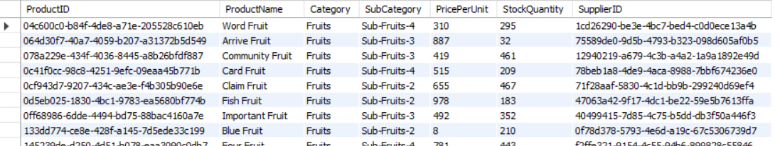 This task demonstrates basic data retrieval for business-specific filtering.

Task 4: Recreate Customers Table with Constraints
Explanation:
This task enforces data validation rules:
- CustomerID as Primary Key ensures uniqueness
- Age NOT NULL and CHECK (Age > 18) ensures valid customers
- UNIQUE constraint on Name avoids duplicate customer names
Constraints improve data quality and reliability.

Task 5: Insert Data into Products Table
Explanation:
INSERT statements are used to add new records into the Products table. This simulates adding new items to Amazon Fresh inventory with category, price, stock, and supplier details.

Task 6: Update Product Stock
Explanation:
The UPDATE statement modifies existing records. Here, stock quantity is updated for a specific ProductID, reflecting real-time inventory changes.

Task 7: Delete Supplier Records
Explanation:
DELETE removes records matching a condition. Suppliers from a specific city are removed, demonstrating controlled data deletion.

Task 8: Add Constraints Using ALTER TABLE
Explanation:
- CHECK constraint ensures Ratings are between 1 and 5
- DEFAULT constraint assigns 'No' to PrimeMember when not specified
These constraints enforce business rules at the database level.

Task 9: Use WHERE, GROUP BY, HAVING, ORDER BY
Explanation:
- WHERE filters orders after a specific date
Output:
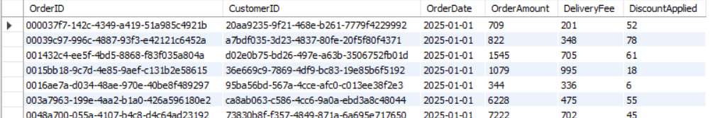
- HAVING filters aggregated results (average rating > 4)
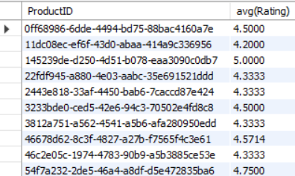
- GROUP BY groups data by Productid
- ORDER BY ranks products by total sales
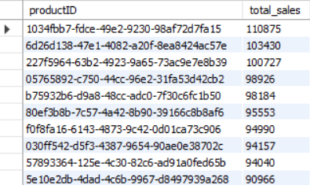
This task demonstrates analytical querying.

Task 10: Identify Top Customers by Spending
Explanation:
- SUM calculates total spending per customer
Output:
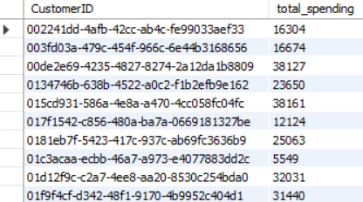
- RANK() window function ranks customers
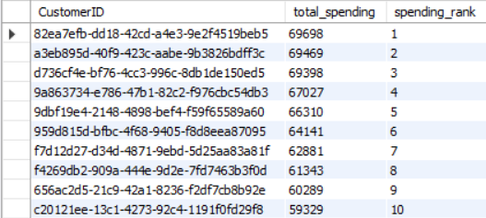
- HAVING filters high-value customers (> ₹5,000)
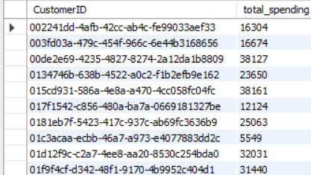
This helps identify premium customers.

Task 11: Join-Based Analysis
Explanation:
- JOIN Orders & OrderDetails to calculate revenue per order
- Output:
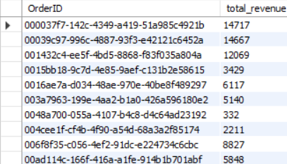
- COUNT orders per customer in a time period
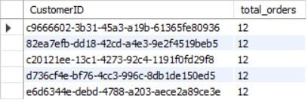
- Aggregate stock quantity to identify top supplier
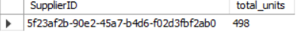
Joins enable multi-table business analysis.

Task 12: Normalize Products Table to 3NF
Explanation:
To remove redundancy:
- Categories and Subcategories moved to a separate Categories table
- Products table references Categories using category_id
Benefits:
- Reduced duplication
- Improved consistency
- Easier maintenance

Task 13: Subqueries
Explanation:
- Subquery calculates total revenue per product, outer query selects top 3
Output :
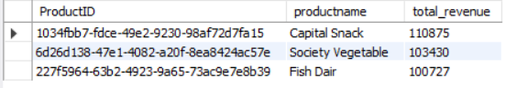
- LEFT JOIN identifies customers without orders
Output:
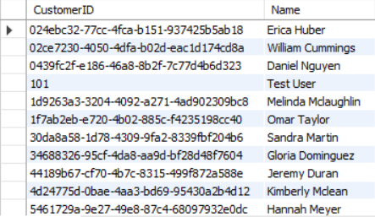
Subqueries help break complex logic into readable steps.

Task 14: Actionable Business Insights
Explanation:
- Prime member concentration helps target marketing
Output:
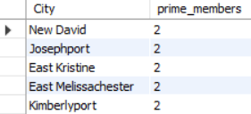

- Frequently ordered categories guide inventory planning
Output:
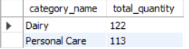
These insights support data-driven decision-making.

Final Conclusion
This project demonstrates end-to-end database skills including ER modeling, constraints, normalization, joins, subqueries, and analytics. The Amazon Fresh database structure supports scalable, accurate, and insight-driven e-commerce operations.
Skills Demonstrated: SQL, Database Design, Normalization, Business Analytics

